JCPenney Data Report 2025

Introduction
In this report, on behalf of JCPenney, we detail our work with existing JCPenney data on products, product reviews and customers to perform exploratory data analysis, draw insights and provide evidence-based recommendations.
This report will cover the following:
- JCPenney business context and our approach to this assignment
- Our findings from exploratory data analysis
- Evidence based recommendations based on our findings

Business Context and Approach
JCPenney is an iconic retailer in the United States with over 650 stores, employing more than 50,000 people. It is one of the largest retailers of apparel, home, jewellery, and beauty merchandise in the United States.
In approaching this work, we set out to draw insights from the data provided which would benefit the business operations of JCPenney. Therefore, our approach was to use data techniques to draw insights in two categories: Product feedback and Customer demographic.
We were provided with a range of data, including:
- Customer date of birth, US State, and JCPenney account username
- Product information, including: SKU references, product descriptions and URL links to the JCPenney webpage
- Review data, including: product average scores and written user feedback
With the data provided, we performed data cleaning and analysis techniques to draw insights from the raw data.

Data Analysis Insights

Product Insights
We used the product and review data provided to ask the questions:
- What JCPenney products receive the best and worst customer reviews?
- Which brands sold by JCPenney are the best and worst reviewed by customers?

Average Product Rating
To explore the best and worst reviewed products, we first calculated the overall average product score, using data analysis techniques to group product data by SKU to visualise a distribution of average reviews:

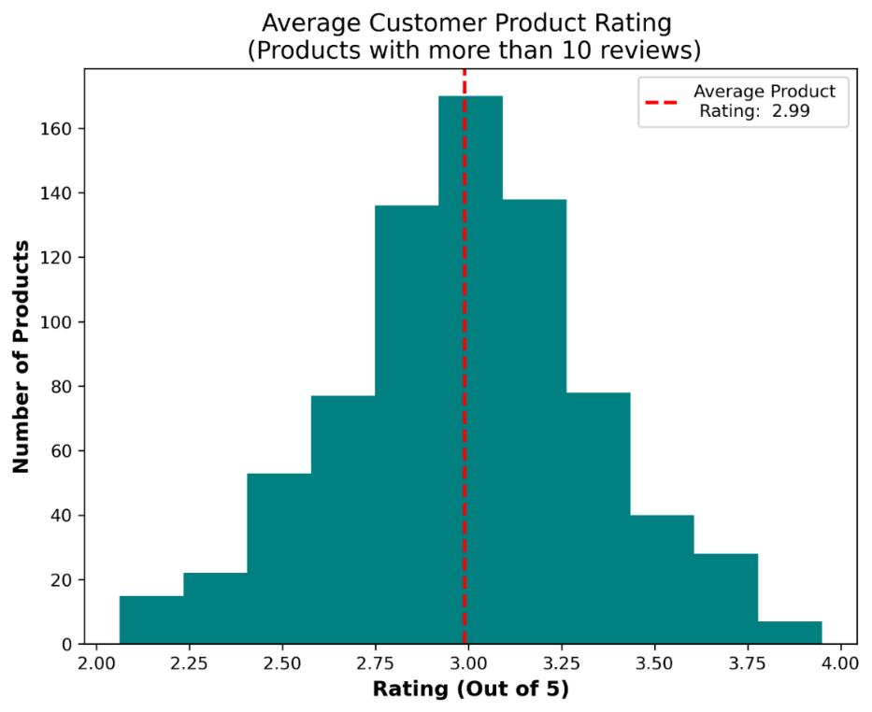
Figure 1
Figure 1 represents a distribution of average product reviews for JCPenney products with more than 10 reviews. We set the filter of more than 10 reviews to only show products with a reasonable review sample size. Using this distribution, we calculated the average product rating.
From the graph, we can see that the average product rating is 2.99/5.

Recommendation
By establishing a baseline for average product rating, if JCPenney takes action to increase customer product satisfaction, an increased average product rating would indicate success. Additionally, the average product rating of 2.99 could be improved by stocking higher quality products which receive better average product ratings.

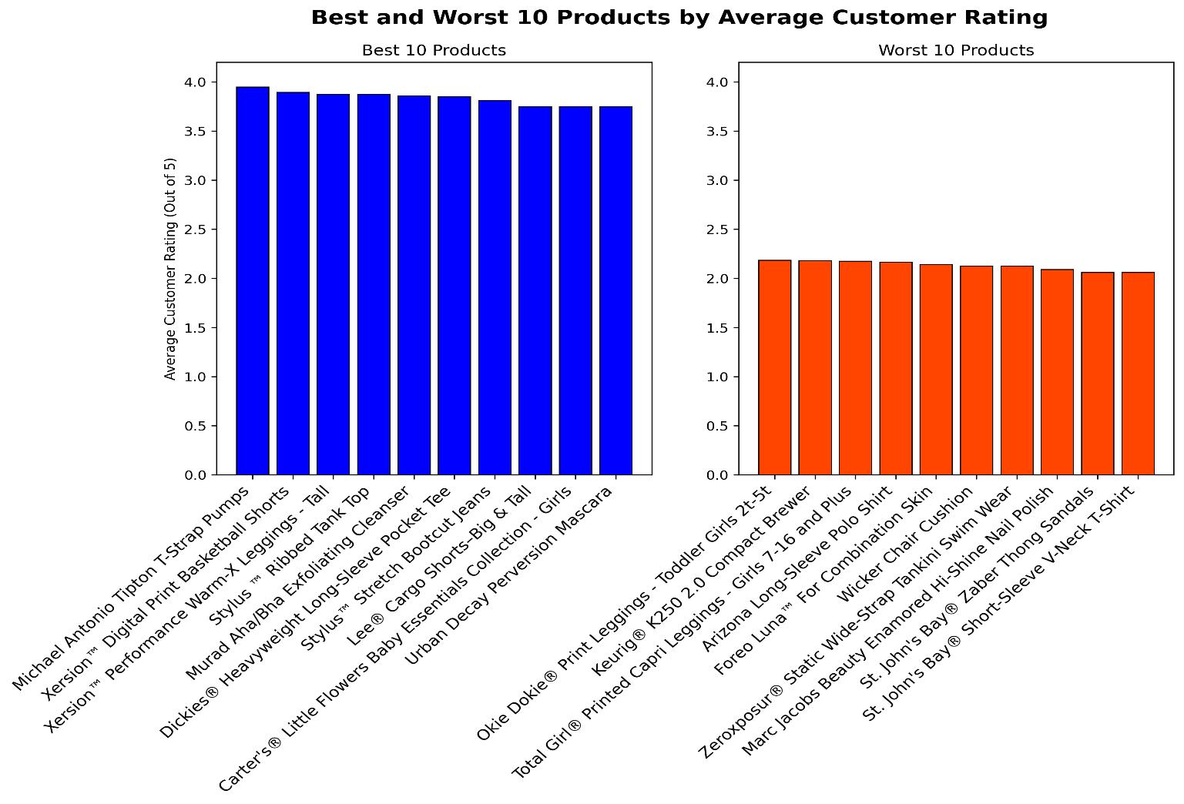
Best and Worst Reviewed Products

Figure 1.1

After establishing a baseline for average product rating, we built on this by using data analysis to identify the 10 best and worst reviewed JCPenney products. Again, we have only included products which have more than 10 reviews so that products have a reasonable review sample size. In this analysis, we look to identify which brands produce products which meet the standard of JCPenney and look to prioritise brands which create higher quality products and therefore increase customer satisfaction.

Recommendation
In order to ensure JCPenney continue to stock high quality products, the sales team should consider whether the worst rated products meet the standards of the company. Additionally, the best 10 products provide a standard for products which meet customer expectations. The JCPenney sales team should look to these products as a bench mark for future stock decisions.

Best and Worst Reviewed Brands Figure 1.2
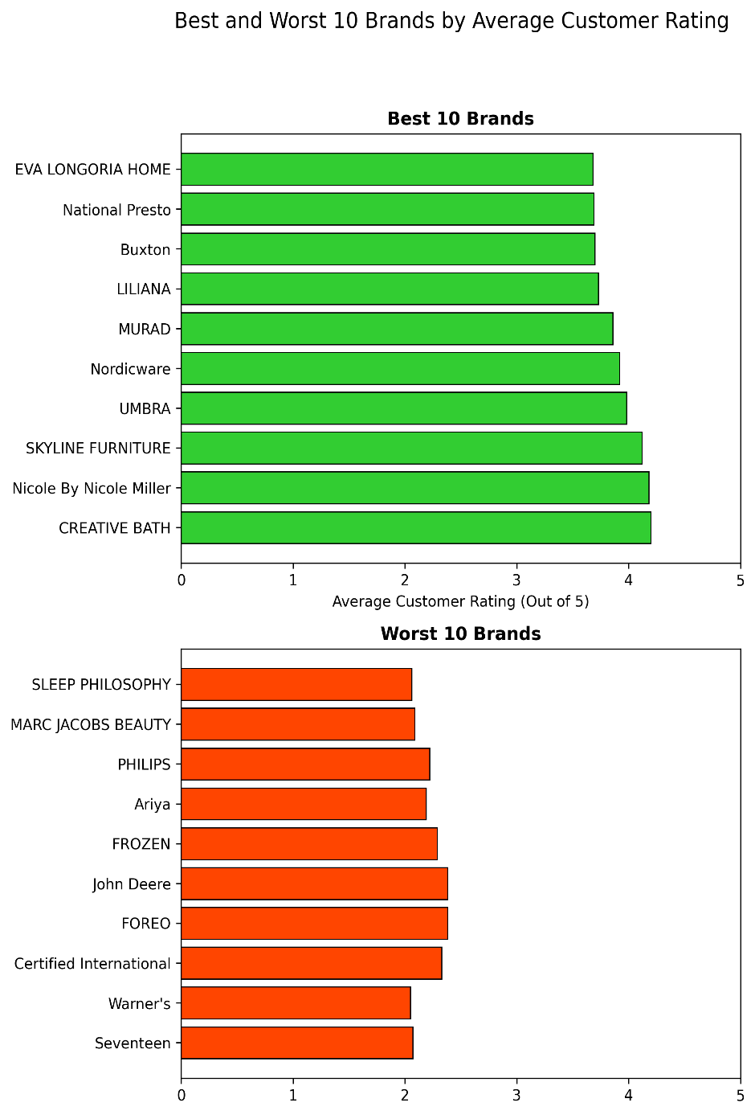
In addition to analysing the best and worst reviewed products by average customer rating, we also used the provided product data to identify the 10 best and worst reviewed brands.

Recommendation
The JCPenney sales team should consider whether the lowest performing brands meet the standards of JCPenney and look to replace these brands with alternatives.
Additionally, the sales team should look to stock more products from the brands which receive high average customer rating. Stocking more items from brands with high average rating may lead to improved overall customer satisfaction.

Customer Insights
With the data provided on Usernames, Dates of Birth, and User State, we were able to draw insights based on customer demographic.

Users by US State
From the data, we know that the usernames included have made at least one purchase from JCPenney as each has an attached review. With this information, we identified JCPenney users, present in the data set, by state. Although explicit customer transaction data is absent from the data, with a sample size of 5000 users, we can draw a reasonable representation of the distribution of JCPenney customers by state. The user counts below show a distribution of the 5000 customers represented in the data. The states with the most and least customers are as follows:
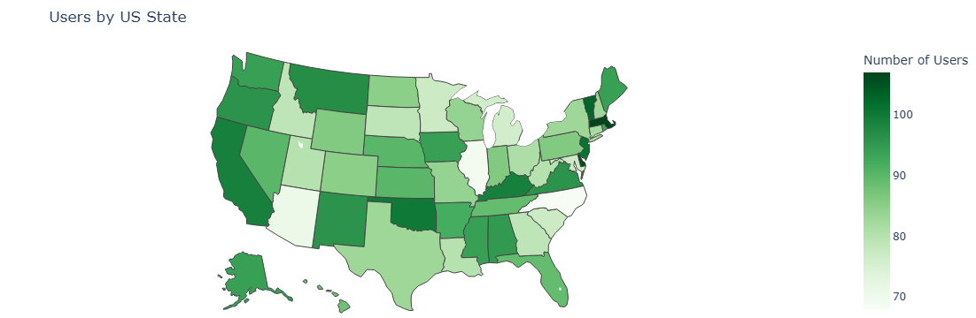

Figure 2
Most Customers | User Count | Least Customers | User Count
Massachusetts | 107 | North Carolina | 68
Delaware | 106 | Illinois | 69
Vermont | 103 | Arizona | 71
Northern Mariana Islands | 102 | Guam | 73
New Jersey | 101 | Michigan | 76
Oklahoma | 100 | South Carolina | 77
California | 99 | Minnesota | 77
Kentucky | 99 | Maryland | 77

Table of top and bottom 10 states by user count included for clarity

Recommendation
To calculate true customers per state, we would need data on all JCPenney customers, however the sample size of 5000 in the data above represents a rough distribution of JCPenney customers. The sales and marketing team should focus efforts to promote JCPenney in the states with least customers to drive sales and customer numbers in these states. The states with the highest user numbers represent an opportunity to be JCPenney’s highest selling stores.

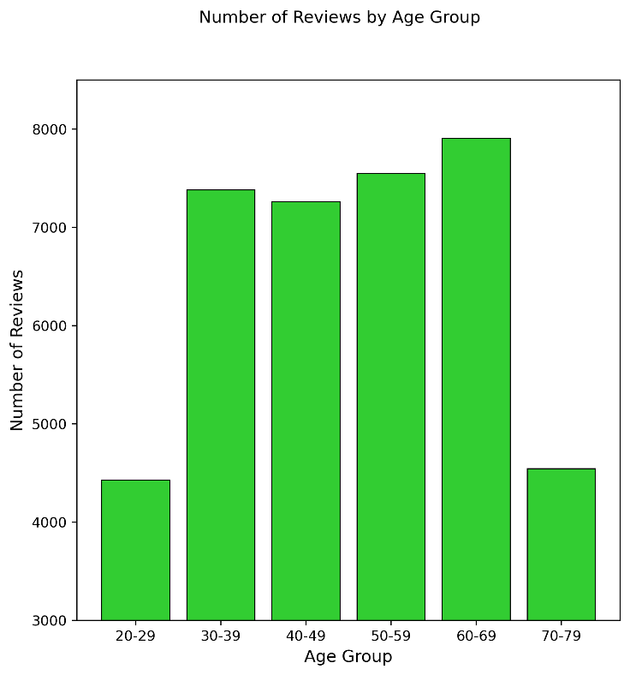
Reviews by Age Group Figure 2.1
With a sample size of 39080 reviews, we were able to draw insights on reviews by age group. This insight could be viewed as an estimate of JCPenney customers by age group, however, the data does not account for customers who bought a product and did not give a review. To get a true value of customers by age group, we would need data on individual transactions by customers and not just reviews.

Recommendation
The data shows that most reviews are left by people between 20 and 69, with the most coming from people who are in the 60-69 age range. Not accounting for those who have bought products without a review, this data could indicate that JCPenney’s main customer base is in the 30-69 age range with least customer in the 20-29 and 70-79 age ranges.
The JCPenney sales team should look to stock products targeted at the 20-29 age bracket, an important customer base. This would look to increase sales within this age demographic. The sales team should investigate whether online marketing, a key tool for reaching this demographic is being utilised fully.

Key Findings and Conclusion
Using the data provided, we were able to answer the questions:
- What are JCPenney’s best and worst reviewed products and brands?
- How are JCPenney users distributed by State and Age Group?
The insights provided on JCPenney’s best and worst reviewed products and brands should serve to influence decision making on product and brand stock. The insights identify which products and brands are meeting the expectations of JCPenney customers and which are falling short. In order to improve overall customer satisfaction, JCPenney should consider which products and brands it stocks.
By understanding more about the demographic and geography of their users, JCPenney can better understand the geographic and age distribution of their customer base. Using this information to design targeted marketing campaigns to reach customers in the States and Age Groups which are underrepresented, increasing sales in these areas and therefore profits.

